Assignment 7

- ACL
1. Configure a Standard ACL to block a particular host from accessing all
connected devices of the second router.
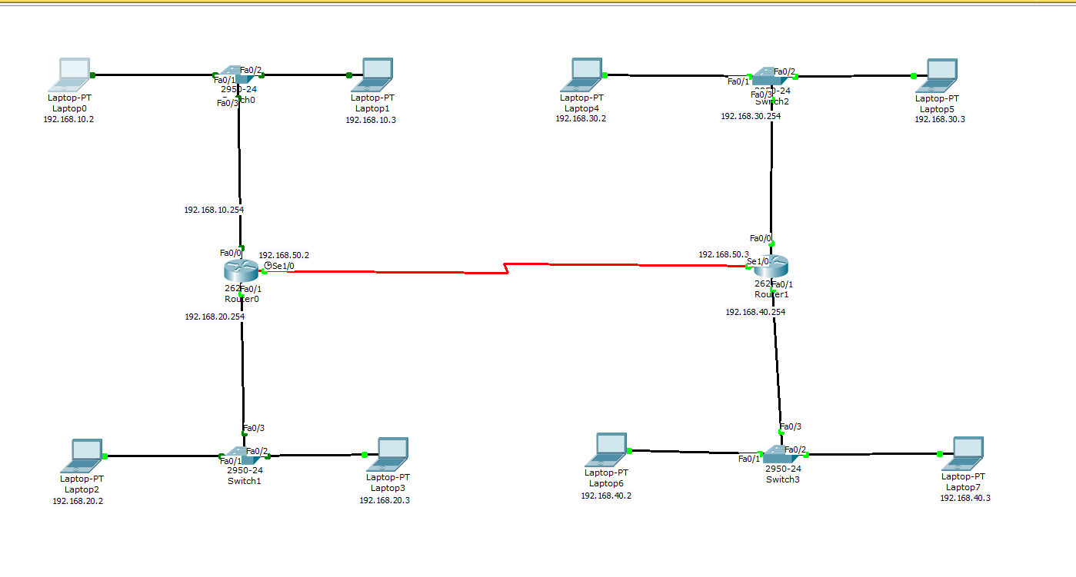
Router 1:
Implementing RIP on router 1

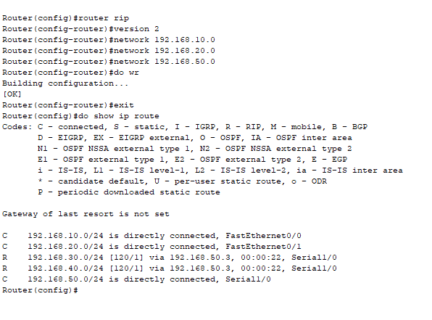
Router 2:
Implementing RIP on router 2
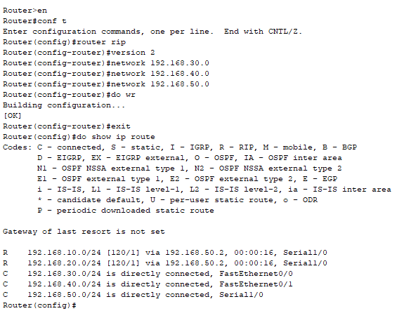
Implementing the Standard ACL
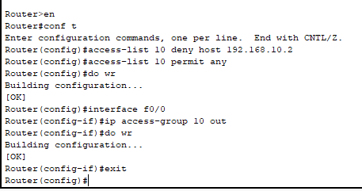
Ping from the PC with ip 192.168.10.2 to PC with ip 192.168.30.2
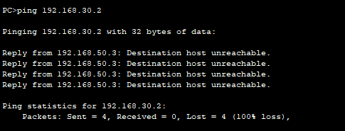
2. Configure an Extended ACL to block one entire network from accessing
another network.
Implementing the Extended ACL
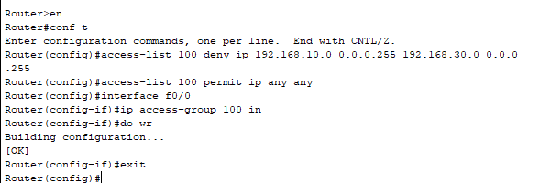
Ping from the PC with ip 192.168.10.2 to PC with ip 192.168.30.2
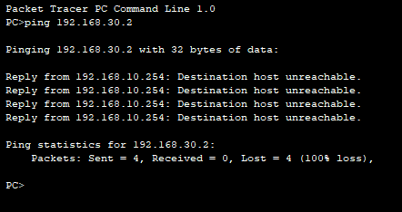

3. Configure an ACL to block services Telnet and HTTP between two
Networks.
Enable telnet on Router 2:
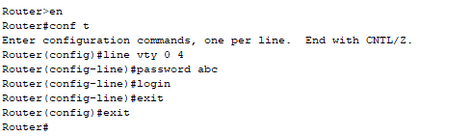
ACL to block services Telnet and HTTP on router 1:
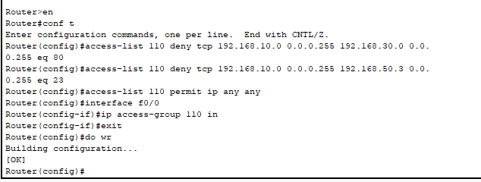

Trying to access Telnet from PC with IP 192.168.10.2 :
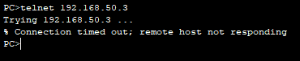

Trying to access the http from PC with IP 192.168.10.2 :
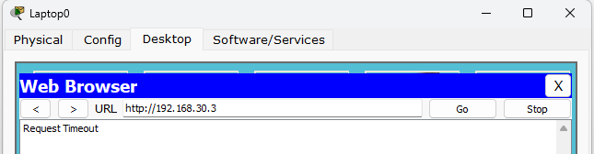

Trying to access Telnet from PC with IP 192.168.20.2 :
Telnet is accessible because we blocked it only for the 192.168.10.0 network.
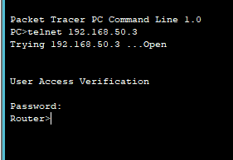

- NAT
1. Configure Static NAT on two routers so that an internal private IP address is
translated to a fixed public IP address.
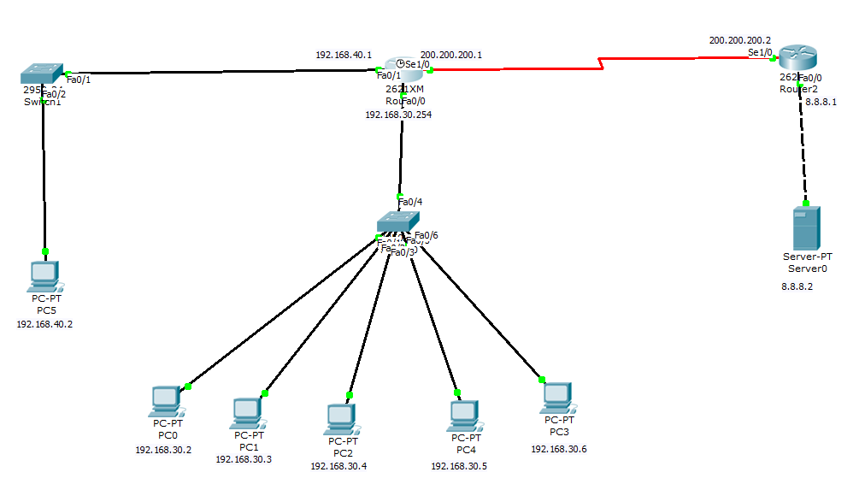
Implement the RIP on both routers:
For Router 1-
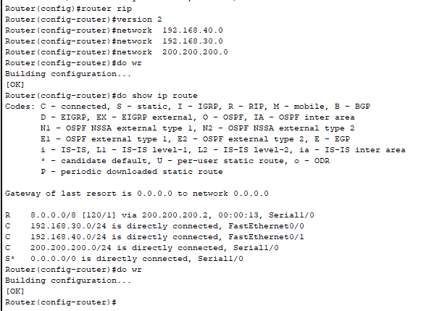
For Router 2-
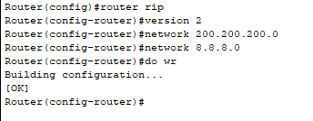

Implementing NAT on router 1-
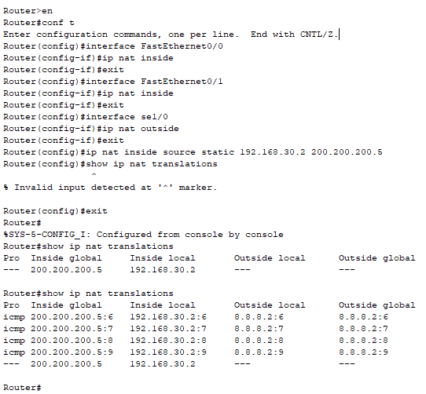

2. Configure Dynamic NAT on two routers so that a pool of public IP
addresses is used to translate multiple private IP addresses.
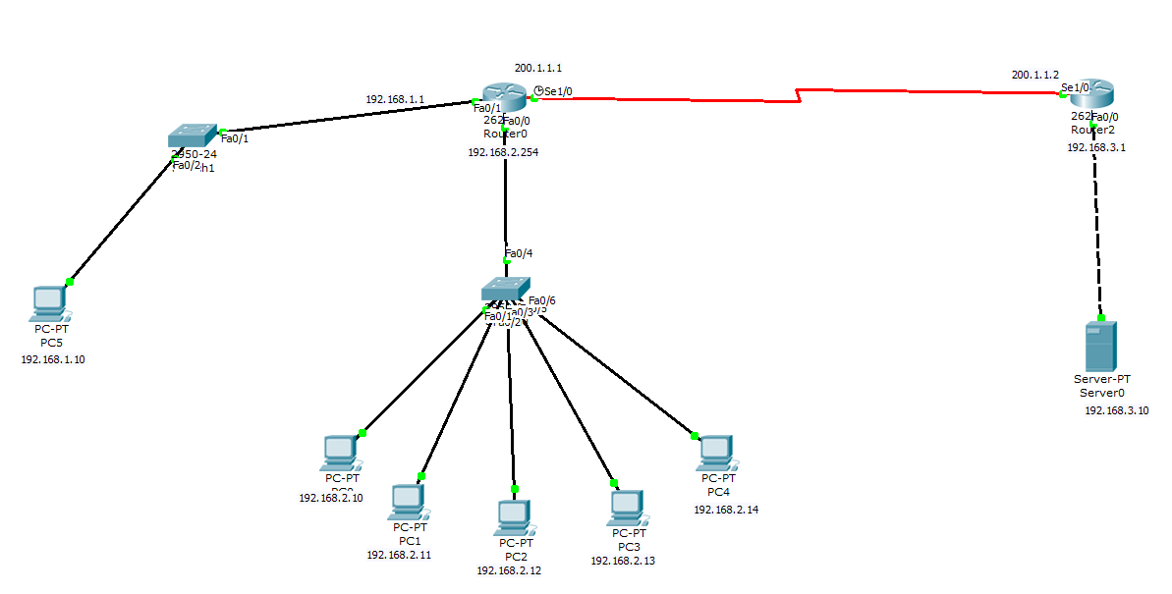
On the Router 0
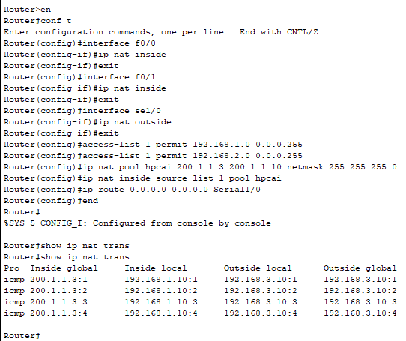

Ping from the PC with IP Address 192.168.1.10 to PC with IP Address 192.168.3.10
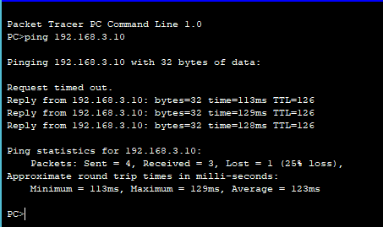

3. Configure PAT (Port Address Translation) on two routers so that many
private IP addresses share a single public IP address using different ports.
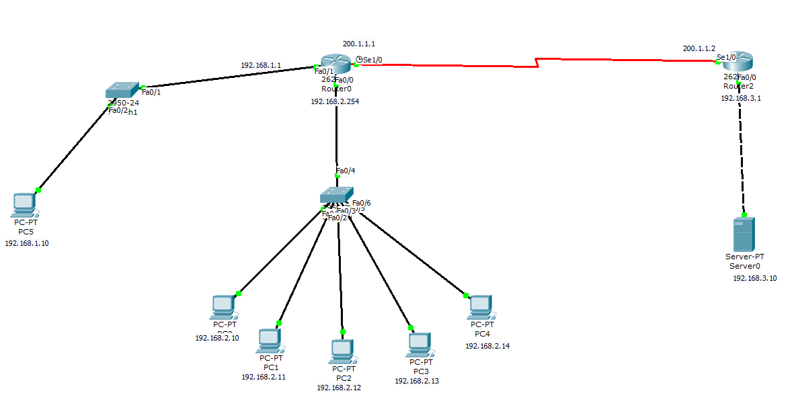
Commands to run on the Router 0:
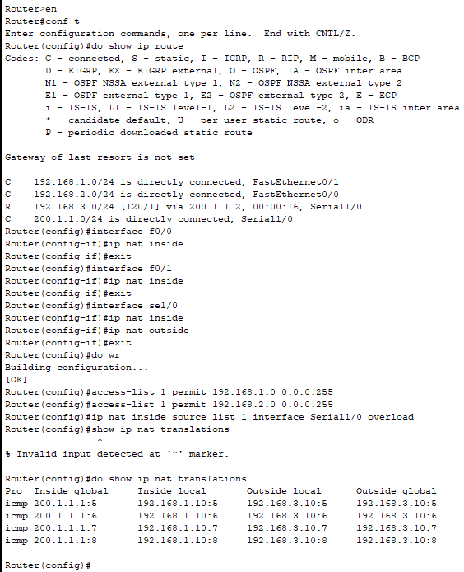
Ping from PC 5 with ip address 192.168.1.10 to PC with ip 192.168.3.10
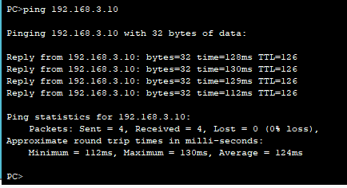

Network:IPV6
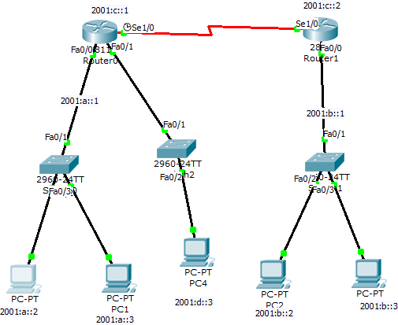

Router1:
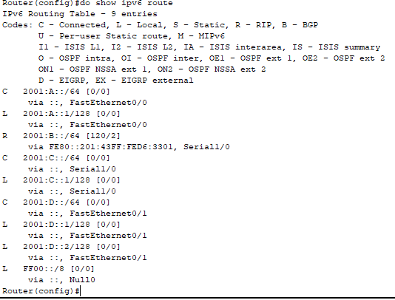
Router(config)#ipv6 unicast-routing Router(config)#ipv6 router rip aditya Router(config-rtr)#int fa0/0Router(config-if)#ipv6ripadityaenableRouter(config-if)#do r

Router(config)#intse1/0
Router(config-if)#ipv6rip aditya enable

Router2:
Router(config)#ipv6 unicast-routing Router(config)#ipv6 router rip aditya Router(config-rtr)#int a0/0
(config-if)#ipv6 rip adityaenable Router(config-if)#do wr

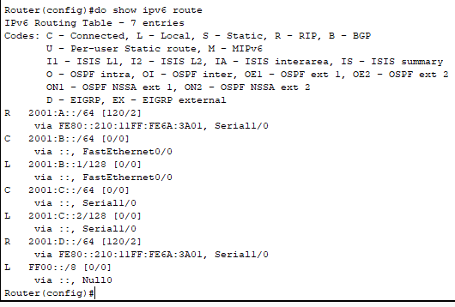

Pinging the a Host from the connected to the another rrouter:
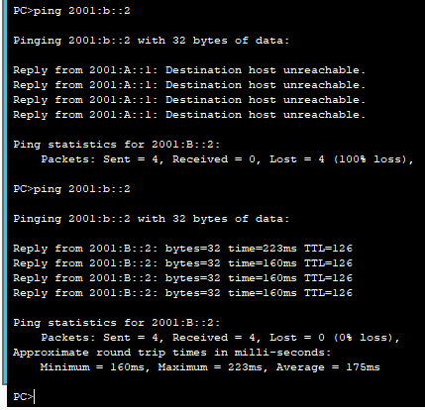
Assignment 8

- VLAN
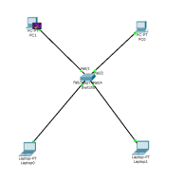
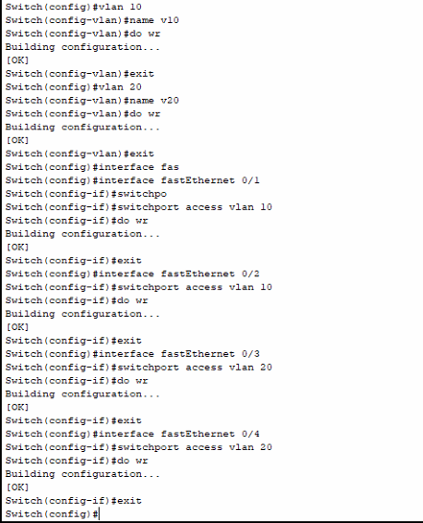
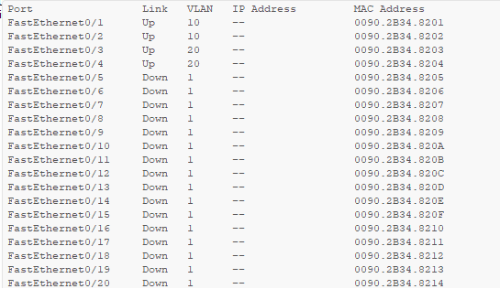
- VTP
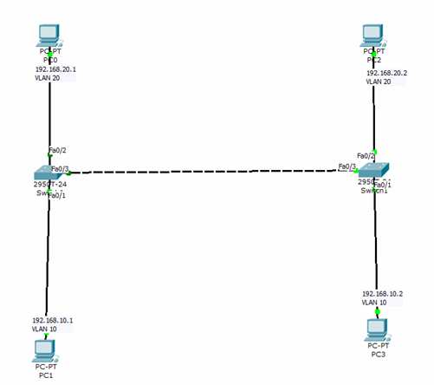
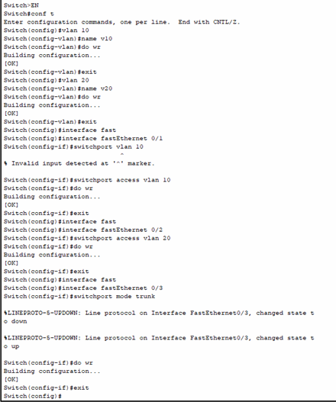
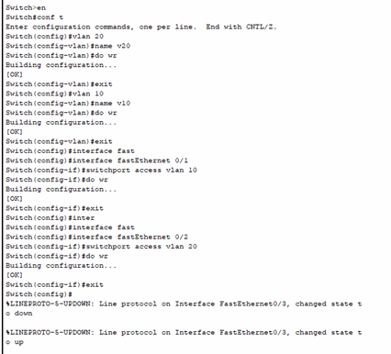
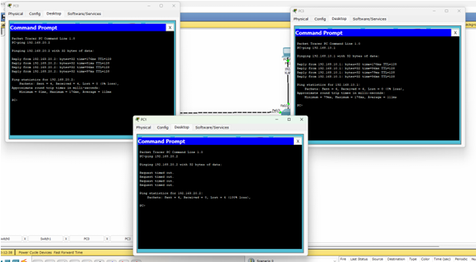

- STP
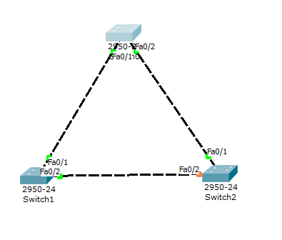
Checking the root (switch 2)

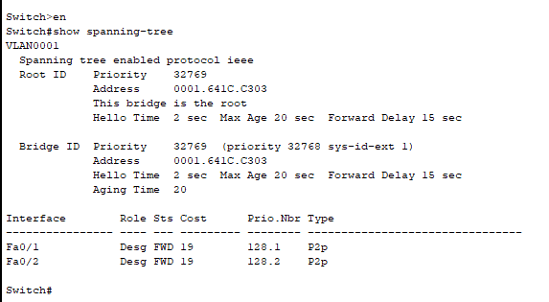
Running on the block switch (switch 1)
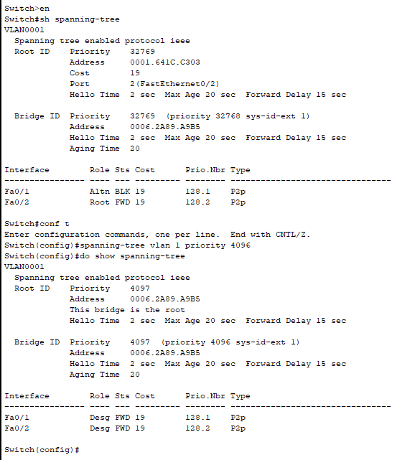

On the switch 0

